

(MENU IS SUBJECT TO CHANGE)
Mon. Sept 16  Ham & Cheese Roll  French fries  Salad  Pineapple  Milk  ______________  Combo | Tues. Sept 17  Enchiladas  Rice  Corn  Lettuce  Mandarin oranges  Milk  _______________  Breakfast bagel | Wed. Sept 18  Steak fingers  Mashed potatoes  Gravy  Wheat roll  Green beans  Tropical fruit  Milk  _______________  French toast sticks |  | Thur. Sept 19  Chicken tetrazzini  Bosco stick  Cooked carrots  Fresh veggies  Pears  Milk  ________________  Maple waffle | Fri. Sept 20  Pulled pork sandwich  Baked beans  Salad  Pickles  Applesauce  Milk  _______________  Pancake on stick
Mon. Sept 23  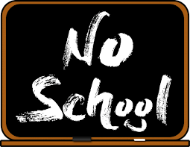  ________________ | Tues. Sept 24  Pig-n-blanket  French fries  Baked beans  Sweet peppers  Mixed fruit  Milk  __________________  Sliders | Wed. Sept 25  Chicken Noodles  Mashed potatoes  Wheat roll  Salad  Peaches  Milk  ____________  Breakfast bites | Thur. Sept 26  Lasagna  Bosco stick  Green beans  Carrots  Fruit cocktail  Milk  ________________  Breakfast pizza |  | Fri. Sept 27  Chicken nuggets  Mac&Cheese  Cucumbers  Strawberries & banana  Milk  ________________  Pop tart or breakfast bar

*This institution is an equal opportunity provider.
**Breakfast served from 7:40-7:55am. Assorted Fruit Juice, Milk and Fruit.
***Lunch guests please call the office before 9am to be added to the lunch count.


